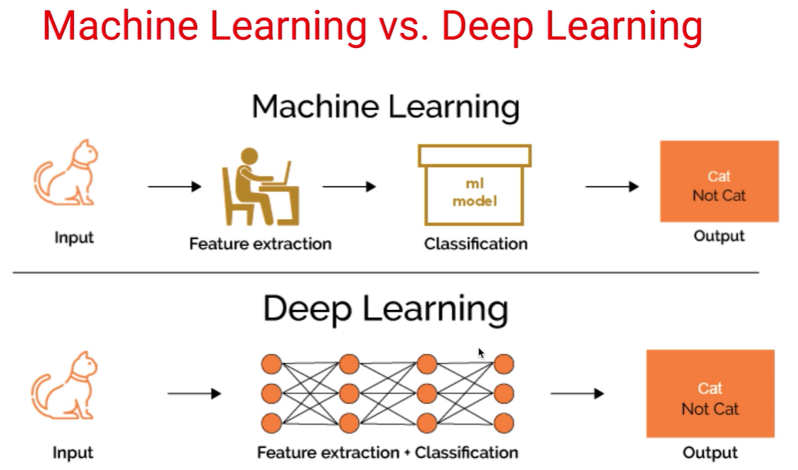

*Deep learning is a particular kind of machine learning that achieves great power and flexibility by learning to represent the world as nested hierarchy of concepts, with each concept defined in relation to simpler concepts, and more abstract representations computed in terms of less abstract ones.*

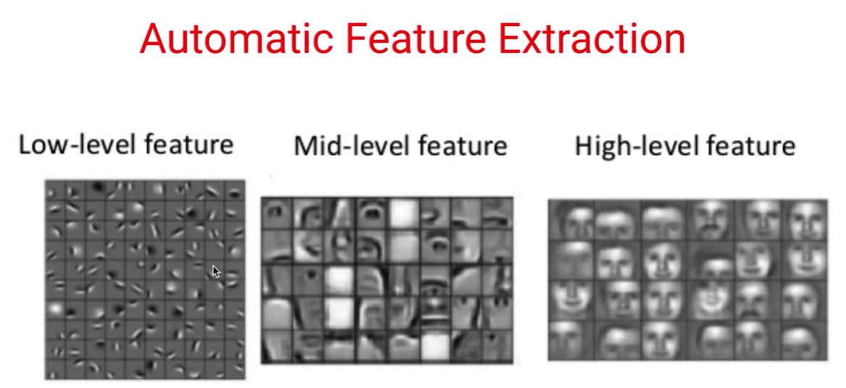

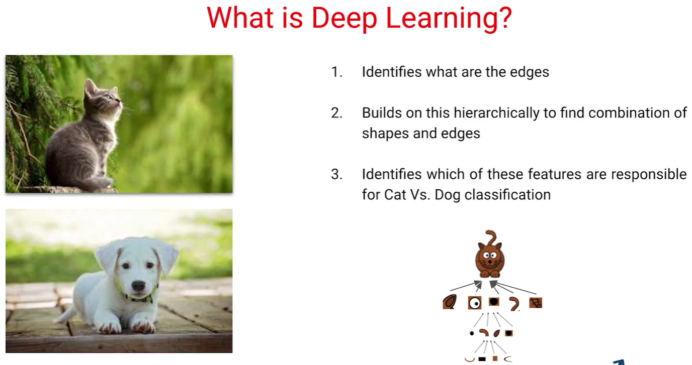

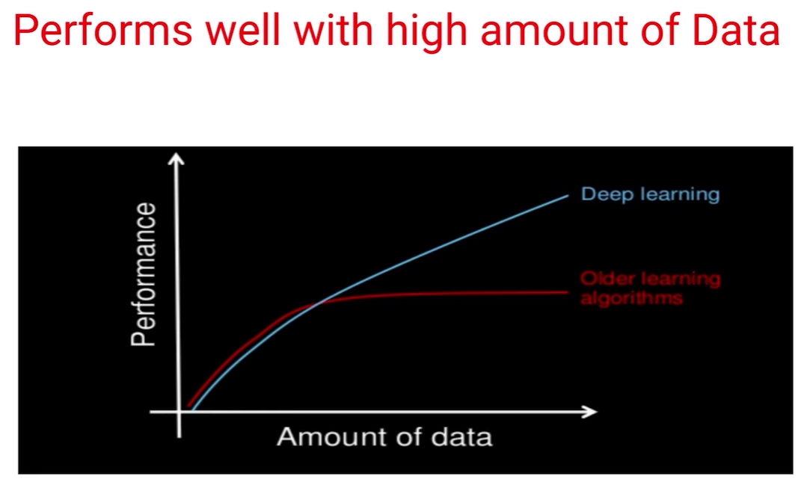

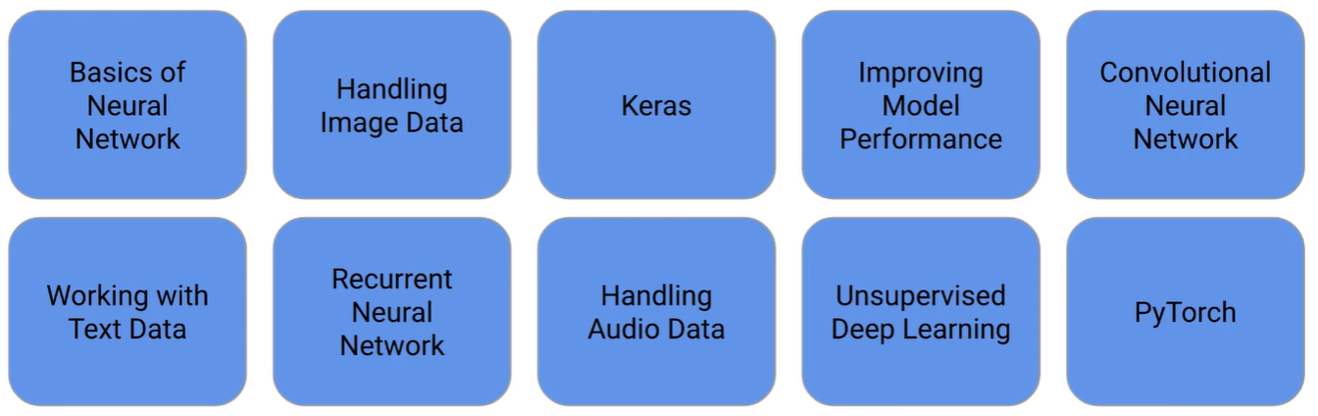

1. Introduction to Deep Learning

* What is Deep Learning?
* Difference b/w Deep Learning and Machine Learning
* Learning and Deep Learning
* Why Deep Learning is so popular?

1. Preparing Environment

* Hardware for Computations in Deep Learning
* Setting up your system
  1. Venv: [Set up virtual environment for Python using Anaconda - GeeksforGeeks](https://www.geeksforgeeks.org/set-up-virtual-environment-for-python-using-anaconda/)
  2. [Tensorflow :: Anaconda.org](https://anaconda.org/anaconda/tensorflow)
* Introduction to Google Colab
  1. [colab.research.google.com](https://colab.research.google.com/notebooks/intro.ipynb#recent=true)
  2. [How to use R in Google Colab | Towards Data Science](https://towardsdatascience.com/how-to-use-r-in-google-colab-b6e02d736497)
* Understanding Google Colab Interface
* Pre-requisites for Deep Learning

1. Introduction
2. Introduction to Neural Network
   1. Perceptron
   2. Weights in Perceptron
   3. Multi Layer Perceptron
   4. Visualizing the neural network (<https://playground.tensorflow.org/> )
   5. Understanding Decision Boundary
   6. Forward and Backward Prop Intuition
   7. Gradient Descent Algorithm
3. Forward and Backward Propagation
   1. Understanding Forward Propagation Mathematically
   2. Understanding Backward Propagation Mathematically
   3. Backward Propagation: Matrix Form
   4. VIDEO•5MlN
   5. Why Numpy?
   6. Neural Network From scratch Using Numpy
   7. Forward Propagation (using Numpy)
   8. Backward Propagation (using Numpy)
   9. Training network (using Numpy)
4. Activation Functions
5. Optimizers
6. Loss Function
7. NN on structured Data
8. Assignment: Big Mart Sales Prediction
9. Functional API in Keras for Deep Learning
10. Getting started with image data
11. Solving Image Classification Using Keras
12. Assignment: Gender Classification
13. Improving your Deep Learning Model
14. Introduction to Convolutional Neural Network and Implementation
15. Introduction to Transfer Learning
16. CNN Visualization
17. Real World Use Cases of Deep Learning